Department | FED
Subject | DSA-2
Academic Year | I-III Semester(2025-26)
Faculty Name | BALAIAH SIR
Student Name | V.CHARISHMA
Roll Number | 2520030140
Branch | CSE
Course Outcome | 4

Case Study Topic: Mumbai–Pune Expressway Dynamic Toll Routing using Dijkstra Algorithm
Work Done Summary:
In this case study, we analyzed dynamic toll routing on the Mumbai–Pune Expressway using Dijkstra’s Algorithm.
The toll plazas considered were:
KIR (Kalamboli), URS (Urse), KHA (Khalapur), TLG (Talegaon), KRD (Karda), DEH (Dehu Road), and PUN (Pune).
The road network consisted of 8 directed edges with toll-based weights. Dijkstra’s Algorithm was executed from
source KIR to destination PUN to determine the minimum cumulative toll path.
A dynamic pricing event was then introduced where the toll on edge URS→TLG increased from ₹18 to ₹40 due to congestion.
The shortest path was recomputed and the effect of the update on the optimal route was analyzed.
Implementation Details:
1. Modeled toll plazas as graph vertices.
2. Represented road segments as directed weighted edges.
3. Executed Dijkstra’s Algorithm from KIR to PUN.
4. Recorded priority queue extraction steps.
5. Calculated cumulative toll cost for the shortest path.
6. Applied dynamic toll update on URS→TLG.
7. Recomputed shortest path after congestion pricing.
8. Compared original and updated routes.
9. Evaluated impact of dynamic edge-weight changes.
10. Verified efficient routing under real-time toll updates.
Result: Screenshots / Output
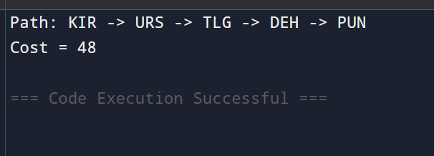
Dijkstra’s Algorithm successfully identified the minimum toll route from KIR to PUN.
After the toll update, the routing engine recomputed the path and verified whether the optimal route changed
Time Complexity : Dijkstra Algorithm: O((V + E) log V)
GitHub Link: https://github.com/virodulacharishma0506-del/DSA--2-Project/blob/main/Main.java
Student Signature | Faculty Signature

